ASSIGNMENT 4

|  |  |
| --- | --- |
| Assignment Date | 10 September 2022 |
| Student Name | Yugesh V S |
| Student Roll Number | 7179KCTKCTKCTKCTKCTKCTKCT19BEC038 |
| Maximum Marks | 2 Marks |

DOCKER PLAYGROUND :-

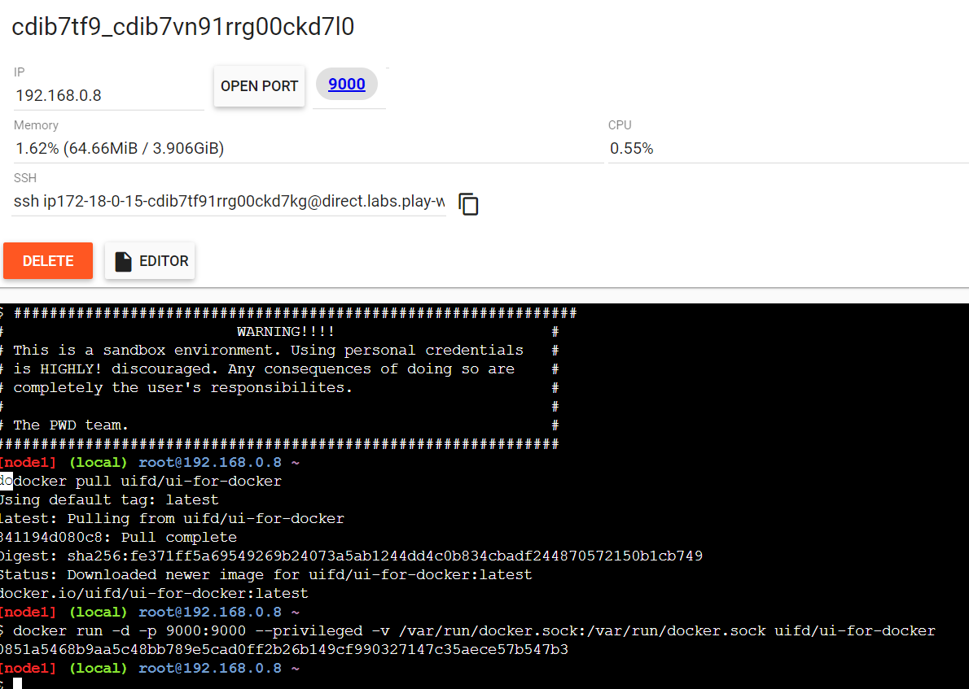

UI USING DOCKER PLAYGROUND

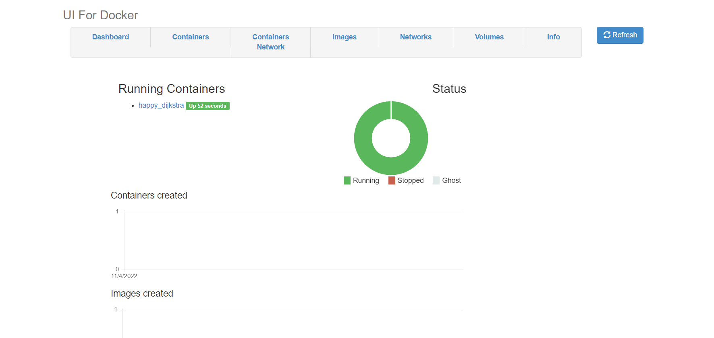

2 .create a docker file and deploy in desktop app

